Jfrog Artifactory Configuration with Jenkins

Cat /opt/maven/conf/settings.xml
In servers location,
<servers>
<server>
<username>admin</username>
<password>Password123</password>
<id>central</id>
</server>
<server>
<username>admin</username>
<password>Password123</password>
<id>snapshots</id>
</server>
</servers>

In Profiles location,

<profiles>
<profile>
<repositories>
<repository>
<snapshots>
<enabled>false</enabled>
</snapshots>
<id>central</id>
<name>mvn-jfrog-libs-release</name>
<url>https://10.100.23.3:8082/artifactory/mvn-jfrog-libs-release</url>
</repository>
<repository>
<snapshots />
<id>snapshots</id>
<name>mvn-jfrog-libs-snapshot</name>
<url>https://10.100.23.3:8082/artifactory/mvn-jfrog-libs-snapshot</url>
</repository>
</repositories>
<pluginRepositories>
<pluginRepository>
<snapshots>
<enabled>false</enabled>
</snapshots>
<id>central</id>
<name>mvn-jfrog-libs-release</name>
<url>https://10.100.23.3:8082/artifactory/mvn-jfrog-libs-release</url>
</pluginRepository>
<pluginRepository>
<snapshots />
<id>snapshots</id>
<name>mvn-jfrog-libs-snapshot</name>
<url>https://10.100.23.3:8082/artifactory/mvn-jfrog-libs-snapshot</url>
</pluginRepository>
</pluginRepositories>
<id>artifactory</id>
</profile>
</profiles>
<activeProfiles>
<activeProfile>artifactory</activeProfile>
</activeProfiles>

In Jfrog Artifactory,
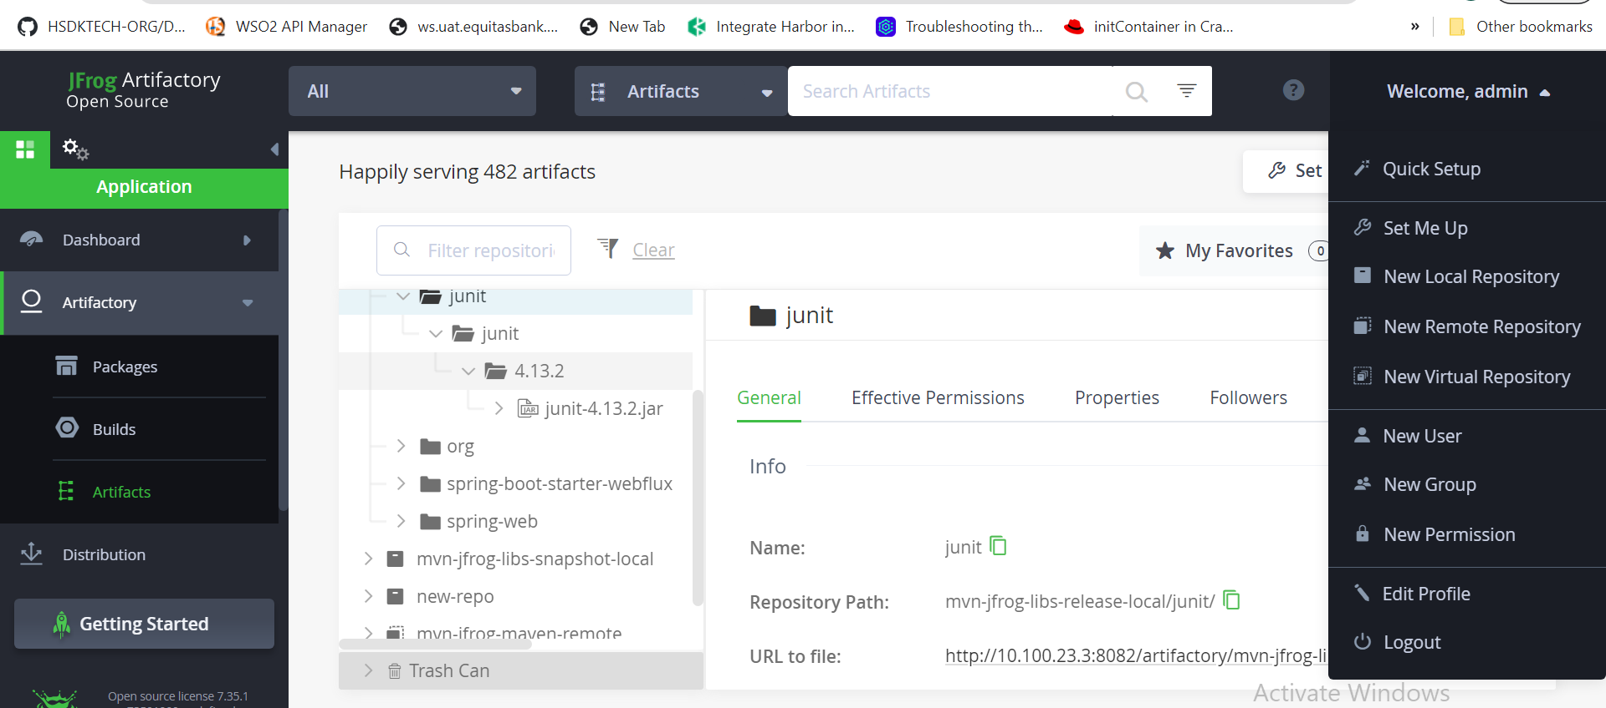
Welcome,admin > Set Me Up
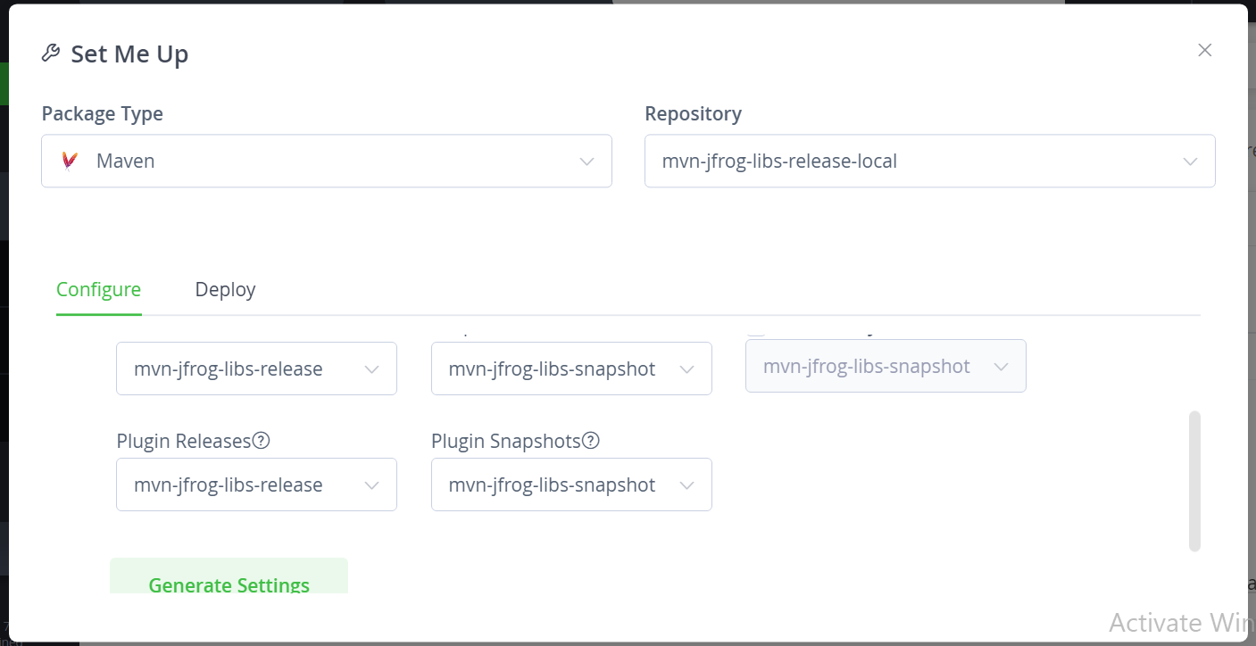

Click on Generate Settings
Download snippet and Pom file will be generated
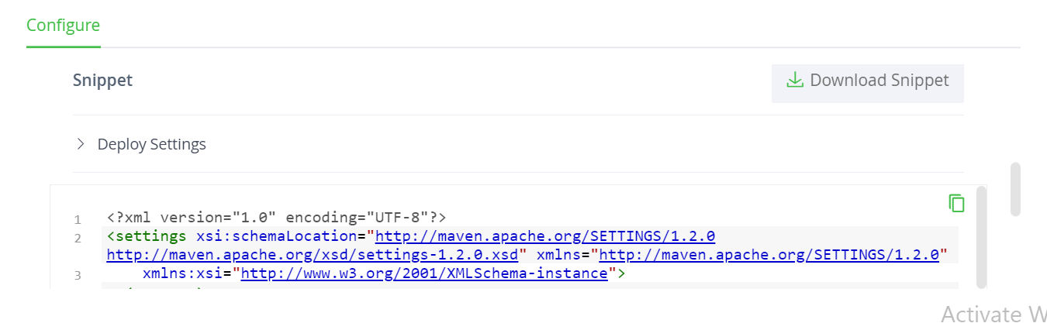
Artifacts deploy,
https://jfrog.com/knowledge-base/artifactory-how-to-upload-a-folder-with-its-content-to-artifactory/
Artifacts download,
https://search.maven.org/

https://www.youtube.com/watch?v=WY29LtVQLhk

